Directions to Andras House

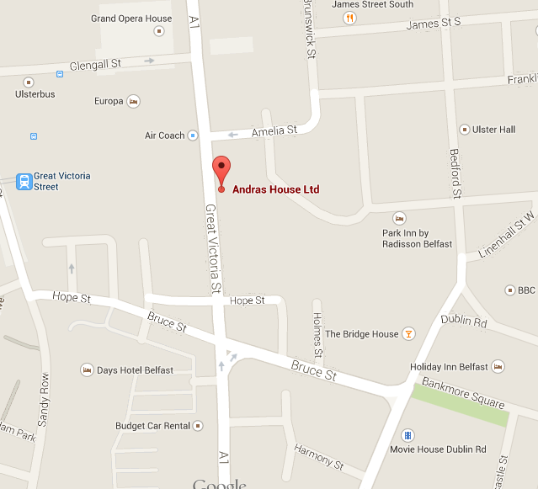

2nd floor
Andras House
Great Victoria Street
Belfast
BT2 7BB

Tel: 028 90895900

https://www.paradescommission.org/

From side entrance of Great Victoria Street train station:
- Turn left onto Hope Street – continue onto Bruce Street – turn left onto Lincoln Square – turn right and walk towards Great Victoria Street – turn left onto Great Victoria Street – Andras House is situated across the street, entrance is beside the Red Panda restaurant.

From Great Victoria Street, bus station:
- Cross Great Victoria Street and turn right, Andras House entrance is beside the Red Panda restaurant.

